INSIGHT 19 Jun 2019

CRU Conference: global politics and trade temper positive cable megatrends

Conferences & Events
CRU’s Wire & Cable Conference held in Brussels 11-12 June highlighted four key takeaways:
- Megatrends like clean energy, electromobility, autonomous drive, electrification, urbanisation, fibre-to-the-home (FTTH) and 5G are driving cable demand and innovation. However, these are being tempered by global political upheaval, trade disputes, government policies and various economic factors resulting in increasingly challenging market conditions for cable producers.
- Of these, the slowdown in China is having the widest effect particularly on the automotive and fibre optic cable sectors. The escalating trade war between the US and China is also starting to make itself felt in the cable market.
- Stakeholders across the cable chain will need to collaborate more closely if they are to achieve the respective country and regional energy generation, transmission and distribution (T&D), as well as communication connection targets.
- The entire cable chain will need to step up R&D and innovation for its products and processes in order to keep up with the various changes brought about by the megatrends outlined above.
Below we have taken some items of interest from the nearly 40 papers presented at the conference which highlight some of the key takeaways mentioned above.
Slowdown in the automotive industry
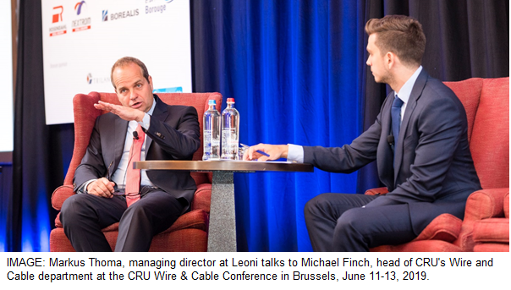
Car producers have been impacted by the slowdown in China, a fall in diesel car sales in Europe and upscaled CO2 emissions targets under the Worldwide Harmonised Light Vehicles Test Procedure (WLTP) ^{[1]}.
In his keynote speech, Markus Thoma, managing director, of Germany’s automotive cable and wiring harness producer Leoni, highlighted that the global automotive market is currently very challenging. He said that automotive cable and wiring harness producers like Leoni have to adapt quickly to the shift in the type of cars that are being built, from the conventional internal combustion engine (ICEs) to hybrid electric vehicles (HEVs) and battery electric vehicles (BEVs).
As a result, the automotive industry has started to slow down over the past few months, with a forecast in August 2018 now revised down to show ~6.3 million fewer light vehicles expected to be made in 2019. This would signify a drop of -0.9% from light vehicle production in 2018. Light vehicle production is only expected to hit the 100 million-unit threshold in 2022, instead of in 2020, as originally forecasted in 2018, said Thoma.
The higher CO2 emission threshold targets for cars, will also speed up the adoption of electric vehicles. The light vehicle market is expected to grow at a CAGR of 2.2% between 2017-2025. In contrast, BEVs will grow at a CAGR of 34% during that period.
However, their market share will remain small, growing from 2.4% in 2019 to 9.9% in 2025. BEV growth will be led by Europe at a CAGR of 36% until 2025, but this will depend on political guiding principles, explained Thoma. HEVs will retain their lead over BEVs, with the latter influenced by drivers’ range anxiety and the higher cost of buying a BEV.
More and higher value wires for electromobility
The move to electromobility, is good news for automotive cable and harness producers as the more electrified the car, the higher the cable content and the more added-value high voltage (>60 V) cables are needed (see table below).
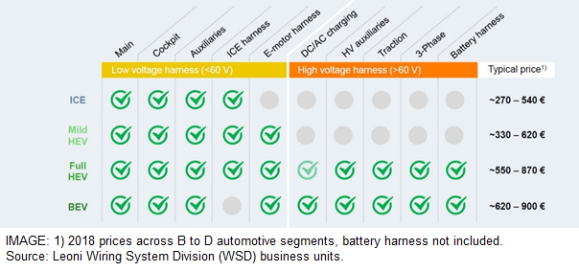
Thoma explained that another trend affecting automotive cables is autonomous drive for which the industry is about to enter level 3, indicating a partial automation of driving (see next image). A higher level of automation (SAE level^{[2]}) demands a system with higher networking speeds. Experts expect an increase of up to 25-Gbp s by 2025 will be required. This will lead to an increase of volume on special data cables.
Automated features and more connectivity will affect a car’s electrical and electronic system (E/E architecture). Most of these have a zonal approach to wire harnesses that simplify the system, centralising the man-machine interface to decrease switches and wire content. This mean less harness complexity opening up opportunities in streamlined production, increased automation at factory level, and simplified logistics, said Thoma.
He expects the wiring harness market for light vehicles (excluding commercial vehicles) to grow around 3% from €42 billion ($47 billion) in 2018 to €49 billion ($54 billion) in 2023, and 1.8% from 2023 to €56 billion ($63 billion) in 2030. Of this, low voltage harnesses will comprise 94% in 2023, with the remaining 6% comprised of high voltage harnesses. By 2030, the share of high voltage harnesses is expected to reach 11%, leaving low voltage harnesses with an 89% share, said Thoma.
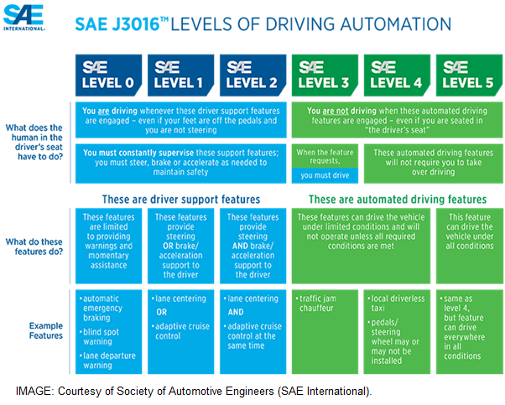
Offshore wind and nuclear to drive cable demand
Richard Mack, principal analyst, CRU, touched on the offshore wind subsea cable market. Mack said that offshore windfarms accounted for 15% of global HV+EHV cable consumption in 2018, and that this percentage will increase to 24% by 2025.
In a separate presentation, Max Yates, research analyst at Credit Suisse said that UK Offshore wind remains the key 2019/20 opportunity for offshore wind orders for European HV+EHV manufacturers. Credit Suisse estimates that key projects in the upcoming months for UK offshore wind orders can generate €1.5 billion ($1.7 billion) of cable orders.
Richard Mack stressed that while Europe will remain a huge market, potential and emerging offshore wind markets are the US, South Korea, Taiwan, Japan, Australia, India and Vietnam. Despite efforts in these markets, Mack said that there is still a lot of work to be done, not just in offshore wind, but all types of renewables.
He explained that excluding hydro-electric, renewable sources accounted for only around 6% – 10% of the world’s energy production in 2018. (BP, IEA, WorldBank) and that after three years of reductions, the world’s carbon output actually went up in 2018.
Andrew Shaw, CEO of the UAE’s Ducab talked about how the company tapped into the country’s need to reduce its dependency on gas and oil and to achieve its Clean Energy Strategy 2050^{[3]} by developing specialty cables for the nuclear industry. The UAE is building four nuclear generators at Barakah^{[4]}.
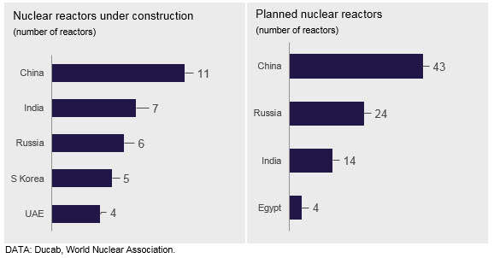
Shaw explained that a big advantage was the support from Ducab’s Board as well as its shareholders Senaat^{[5]} and the Investment Corporation of Dubai^{[6]}. It required a complete overhaul of Ducab’s existing technological expertise as well as close collaboration with various parties, including the Emirates Nuclear Energy Corporation (ENEC).
The result was a nuclear cable product portfolio that has provided it with $70 million of business to date, as well as entry into the international nuclear market, which is growing at a steady pace. Shaw provided some figures for the number of nuclear reactors to be built, with China, India and Russia currently having the most reactors under construction and under planning (see charts).
Land cables suffer objections
Laurent Schmitt, secretary general of ENTSO-E^{[7]}, stressed the need for more grid infrastructure in Europe to meet clean energy targets. He said that 80% of the projects in ENTSO-E's 10 year network development plan (TYNDP2018)^{[8]} are justified by renewables' integration. Nevertheless, many of these projects are delayed, due to public opposition at a local level, particularly for land based transmission, mainly for overhead transmission lines.
Volker Wendt, director of public affairs at cable industry association, Europacable, said in a different presentation that local opposition to land projects makes up over 30% of the delays and that undergrounding is a solution to sensitive areas. He said that Germany’s land interconnectors SuedOstLink and SuedLink are good examples of partial undergrounding. There are about 20 projects in Germany which involve partial undergrounding.
Schmitt however argued that resolving such issues by undergrounding cables is not always possible due to the cost, complexity and maintenance issues. To mitigate this, best practice includes stakeholder engagement based on local needs and the re-engineering of projects based on stakeholder input.
Wendt stressed undergrounding should be part of a “TSOs toolbox”. He explained that €150 billion ($168 billion) grid investment is needed by 2030, and warned that the cost of not having a fully integrated EU electricity grid is estimated at €43 billion ($48 billion) per year. He also pointed out that about 43% of route-length the EU needs to be building over the next decade will be subsea based, which is good news for producers with these capabilities.
China still the largest cable market, despite slowdown
Chenfei Wang, analyst, wire and cable at CRU outlined the ramifications of the slowdown in China and the ongoing trade war with the US on the wire and cable market. He explained that despite the slowdown, China will continue to be the world’s largest producer, consumer and exporter of wire and cable.
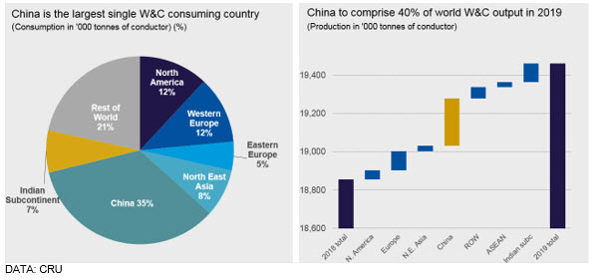
In 2019, China is expected to account for 35% of global wire and cable consumption, and 40% of global production. This means its wire and cable production is bigger than N. America, Europe, N. E. Asia and the ASEAN region combined. “One key takeaway from this, is that China will remain critical to the global wire and cable industry,” explained Wang.
Chinese W&C industry to see massive shift
Chinese wire and cable demand will remain robust in 2019 with a growth rate of 3.9%y/y, which is still higher than other world regions at 3.2% y/y (see left hand chart below). LV energy cable and power cable together represent more than 70% of China’s wire and cable consumption, followed by winding wire at around 25%, said Wang.
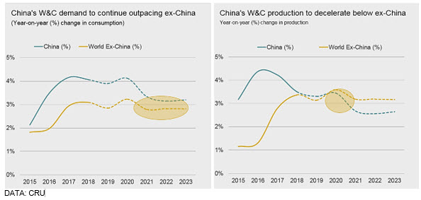
However, there are significant downside risks associated with this forecast due to the escalation in trade tensions with the US and the lower-than-expected state grid investment so far this year.
Looking beyond 2020, China’s GDP growth will slow to below 6%, while IP growth is forecast to decelerate at an even faster rate than GDP growth (see chart below). These factors will all act as headwinds to the Chinese wire and cable market, causing the gap between China and ex-China wire and cable demand growth to narrow (see left hand chart above).
As shown in the chart on the right hand side above, from 2020, China’s insulated metallic wire and cable production will for the first time since CRU started collecting data on China in the 1990s, grow at a slower rate than the rest of the world.
This is a massive structural shift for the wire and cable industry, Wang pointed out. He explained that slowing demand growth, a decrease in government spending, reduced market access and increased competition in export markets, will be the main reasons for this shift, which might even happen in 2019, due to the escalation in the trade war between China and the US.
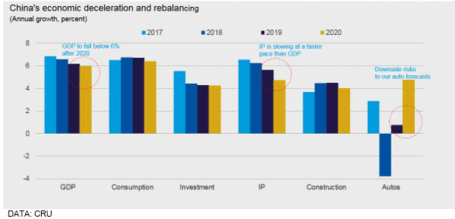
Trade tariffs to impact Chinese W&C exports from 2019
“We believe that the trade tariffs on Chinese imports into the US implemented since mid-2018 will also turn export growth negative in 2019,” said Wang. He added that the trend is evolving rapidly.
“Using the latest trade statistics for Q1 2019, we forecast that US wire and cable imports from China will decrease by as much as 36% in H1 2019 compared to H1 2018. This is based on the broad assumption that Q2 imports will be equal to Q1,” added Wang.
“But we can’t rule out the possibility that US importers may decide to continue importing from China and just pass on the additional costs to end-users,” said Wang. He added that exports only accounted for around 16% of China’s total insulated metallic wire and cable production in 2018. “It’s a significant amount, but perhaps less than a lot of people think,” Wang said.
LV energy cable and winding wire will be hit the hardest by the tariffs. Whilst this may present opportunities for domestic US producers and other trade partners, it will be at the expense of Chinese wire and cable manufacturers and speed up industry consolidation, Wang concluded
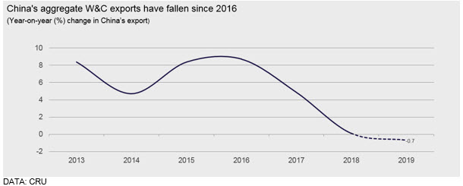

Notes:
- [1] - On 17 April 2019, the European Parliament and the Council adopted Regulation (EU) 2019/631 setting CO2 emission performance standards for new passenger cars and for new light commercial vehicles (vans) in the EU for the period after 2020. The new Regulation will start applying on 1 January 2020. For further information: https://ec.europa.eu/clima/policies/transport/vehicles/cars_en
- [2] - SAE International, initially established as the Society of Automotive Engineers, is a US-based, globally active professional association and standards developing organization for engineering professionals in various industries.
- [3] - The strategy aims to increase the contribution of clean energy in the total energy mix from 25% to 50% by 2050 and reduce the UAE’s carbon footprint of power generation by 70by 2050. It also seeks to increase consumption efficiency of individuals and corporates by 40%. https://government.ae/en/about-the-uae/strategies-initiatives-and-awards/federal-governments-strategies-and-plans/uae-energy-strategy-2050
- [4] - Four nuclear reactors are simultaneously being built at Barakah. On March 31, 2019, Enec said that the construction of unit 1 is complete, while units 2-4 are approaching construction completion with overall plant construction standing at over 91%. https://www.enec.gov.ae/news/latest-news/next-stage-of-testing-completed-at-unit-2-of-barakah-nuclear-energy-plant/
- [5] - Senaat, which is an Arabic word for “industries”, is one of the UAE’s largest industrial investment holding companies. Owned by the Government of Abu Dhabi, Senaat is mandated to create, acquire and optimise industrial businesses in Abu Dhabi. It operates in four key industrial sectors: metals, oil and gas services, construction and building materials and food and beverages manufacturing.
- [6] - The Investment Corporation of Dubai is a state-owned holding company that can be characterized as a sovereign wealth fund owned by the government of Dubai, UAE. Established in May 2006 with the transfer of the government's portfolio of investments from The Department of Finance's Investment Division, its role is to supervise the government's investment portfolio while adding value.
- [7] - ENTSO-E, the European Network of Transmission System Operators for Electricity, represents 43 electricity transmission system operators (TSOs) from 36 countries across Europe. ENTSO-E was established and given legal mandates by the EU’s Third Legislative Package for the Internal Energy Market in 2009, which aims at further liberalising the gas and electricity markets in the EU. https://www.entsoe.eu/
- [8] - The 2018 Ten Year Network Development Plan (TYNDP2018) is adopted by ENTSO-E and publicly released on 19 November 2018 after a public consultation that ended on 21 September 2018. It is subsequently submitted to the Agency for the Cooperation of Energy Regulators according to Regulation (EC) No 714/2009. https://tyndp.entsoe.eu/tyndp2018/

